Smart Gram Panchayat Portal

- Functionality :-

- Citizen Management
- Certificate Management
- Complaint Management
- Notice Management
- Government Scheme Management
- User & Role Management
- Audit/Activity Tracking

- Entities :-

- User
- Role
- Certificate
- Certificate Type
- Certificate Document
- Complaint
- Complaint Category
- Complaint Image
- Complaint Feedback
- Notice
- Government Scheme
- Audit Log
- Attributes :-

- User :- userId, fullName, email, mobileNumber, password, dateOfBirth, gender, address, isActive, createdAt, updateAt
- Role :- roleId, roleName, description
- Certificate Type :- certificateTypeId, typeName, description
- Certificate :- certificateId, applicationNumber, purpose, status, remarks, appliedDate, approveDate
- Certificate Document :- documentId, documentName, filePath, uplodedDate
- Complaint :- complaintId, title, description, location, status, createdAt, resolvedAt
- Complaint Category :- categoryId, categoryName, description
- Complaint Image :- imageId, imagePath, uplodedAt, imageType
- Complaint Feedback :- feedbackId, rating, comment, submittedAt
- Notice :- noticeId, description, attachmentPath, publishDate, expiryDate, createdAt
- Government Scheme :- schemeId, schemeName, description, eligibilityCriteria, benefits, applicationProcess, applicationLink, lastUpdated
- Audit Log :- logId, entityName, entityId, timestamp, ipAddress

- Table Structure :-

- Users
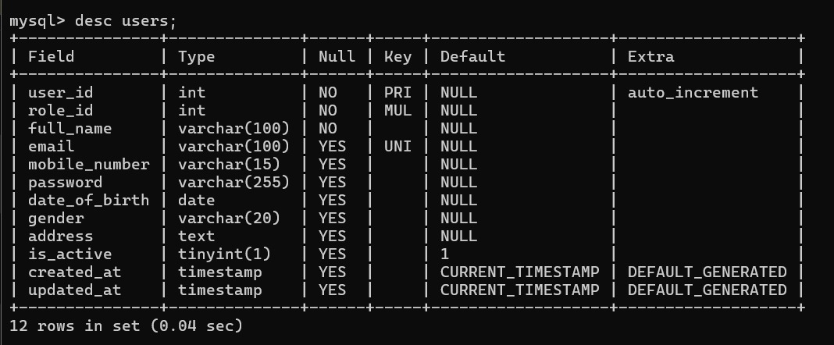

- Role
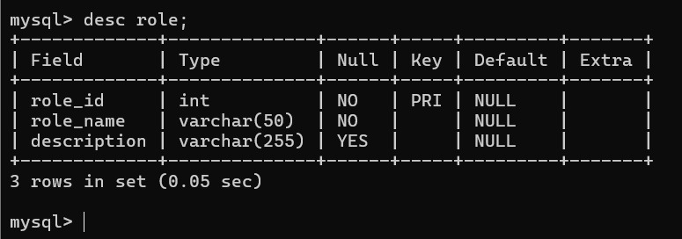

- Certificate Type
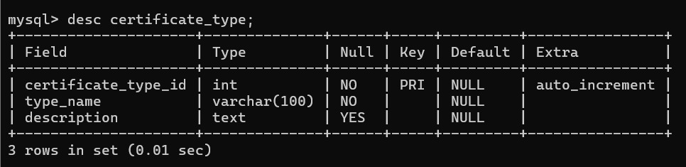

- Certificate
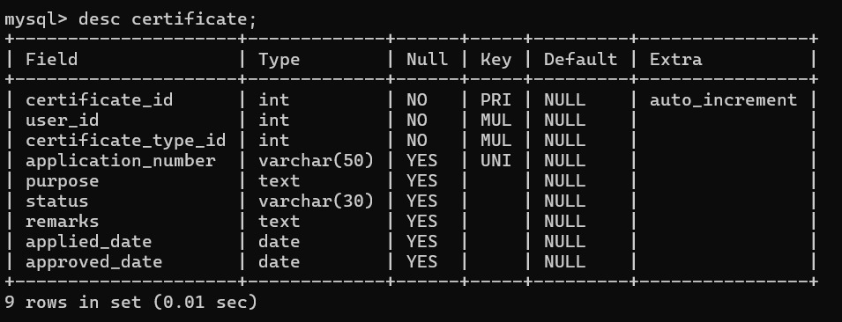

- Certificate Document
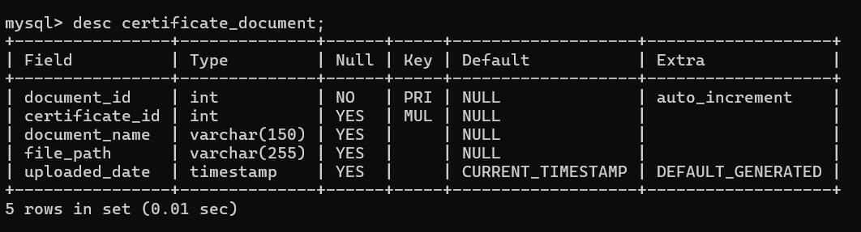

- Complaint
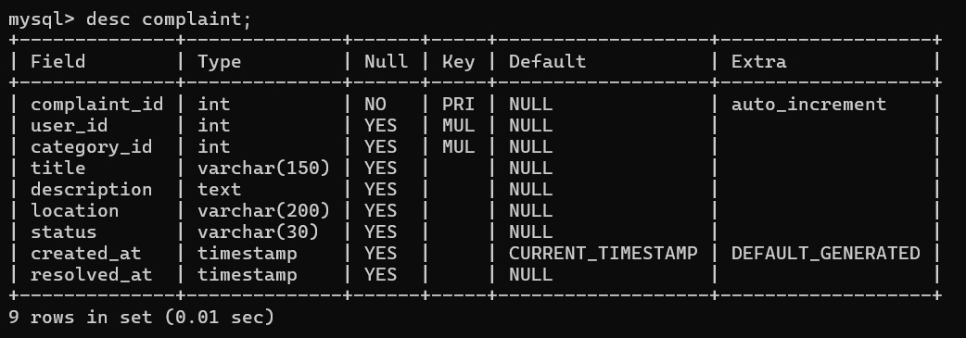

- Complaint Category
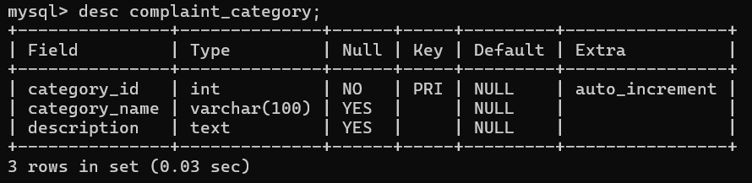

- Complaint Image
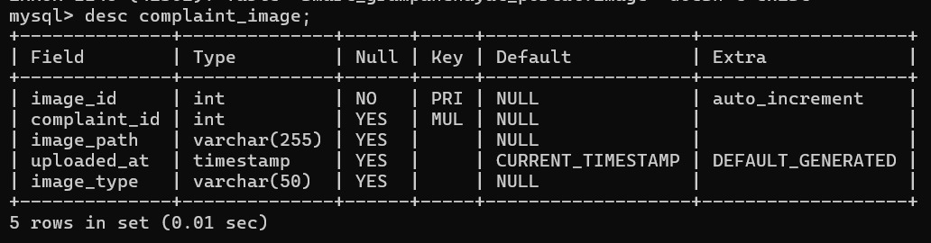

- Complaint Feedback
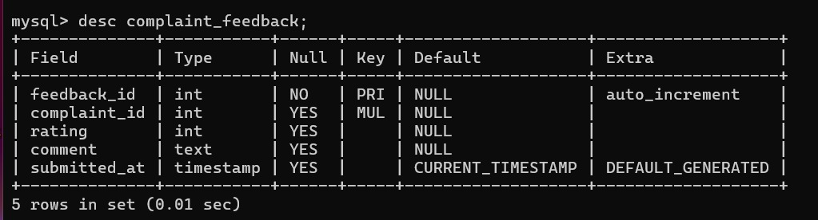

- Notice
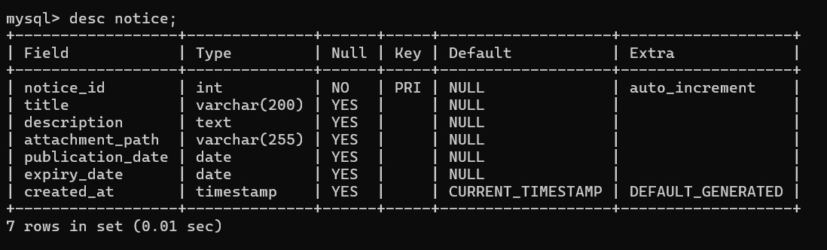

- Government Scheme
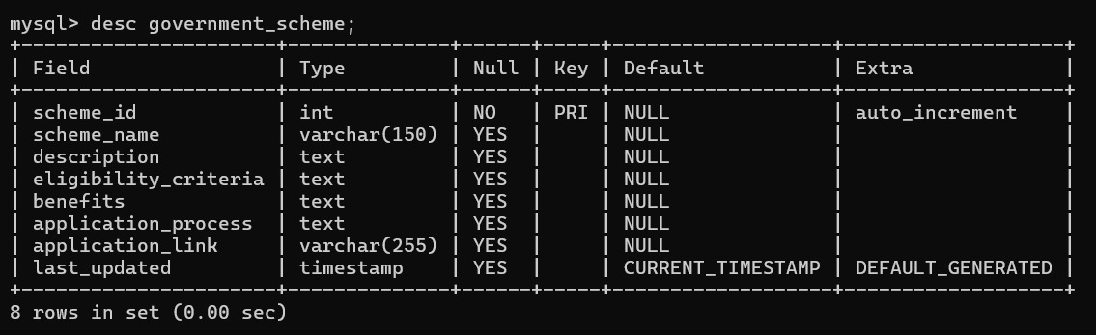

- Audit Log
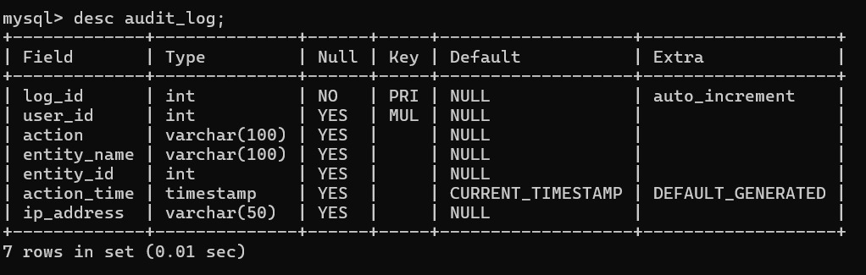

- Tax
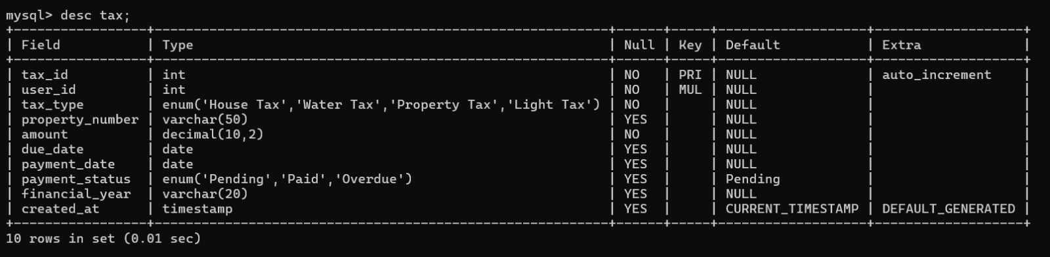

- ER Diagram :-
